**Web Technology Session 11-09-2023**

**Topic 1 – Forms:**  Practice all different type of input tag

**Code:**

<h3>KJ Somaiya Institute of Management</h3>

<div class="container">

<form action="" id="form--id" class="form--class" accesskey="q" tabindex="1" onchange="">

<fieldset>

<legend>Registration Form</legend>

<input type="text" placeholder="Enter Department" />

<input type="email" placeholder="Enter Email" />

<input type="password" placeholder="Enter Password" />

<input type="date" placeholder="Select Date" />

<input type="datetime" name="" id="" placeholder="Select Datetime" />

<input type="datetime-local" id="" name="" placeholder="Enter DOB" />

<input type="color" name="" id="" placeholder="Enter Color" />

<input type="file" multiple />

<input

type="image"

src="icon.png"

height="50"

width="50"

placeholder="select image"

alt="image"

/>

<input type="month" name="" id="" />

<input type="week" name="" id="" />

<input type="time" />

<input type="url" name="" id="" placeholder="URL" />

<input type="tel" name="" id="" placeholder="tel" />

<input type="search" name="" id="" placeholder="search" />

<input type="range" name="" id="" min="1" max="10" />

<input type="number" name="" id="" placeholder="Enter Number" />

<input type="hidden" name="" placeholder="this tag is not visible" />

<div style="display: flex">

<input type="radio" name="gender" id="" value="male" />Male

<input type="radio" name="gender" id="" value="female" />Female

</div>

<div style="display: flex">

<input type="checkbox" name="course" id="" />Web Technology

<input type="checkbox" name="course" id="" />DB Application

<input type="checkbox" name="course" id="" />Python

</div>

<textarea name="" id="" cols="30" rows="3" style="display: block;"></textarea>

<select name="" id="">

<option value="Mumbai">Mumbai</option>

<option value="Delhi">Delhi</option>

<option value="Banglore">Banglore</option>

</select>

<input type="button" value="Submit" />

<input type="reset" value="Reset" />

<input type="submit" value="Register" />

</fieldset>

</form>

</div>

Add in image area map

Framset (deprecated)

<html>

<frameset rows = "20%, 60%, 20%">

<frame src="index.html">

<frame src="header.html">

<frame src="footer.html">

</frameset>

</html>

<html>

<body>

<object data="https://www.youtube.com/embed/qz0aGYrrlhU" width="300" height="200"></object>

</body>

</html>

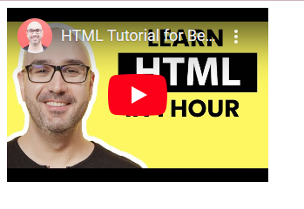

<iframe

name="iframe"

src="./topic-3.html"

frameborder="0"

width="500"

height="400"

></iframe>

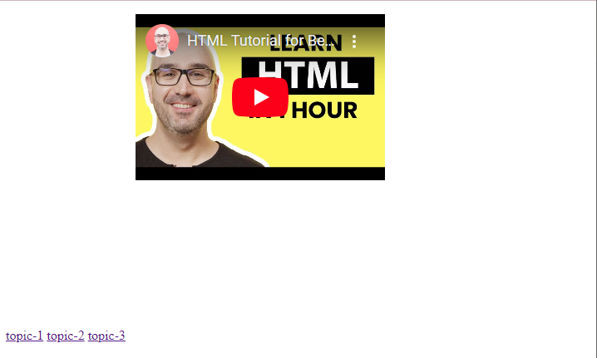

Topic 2 – Events

<script>

document.write(

`<h1 style="background:#ccc;color:black;">Learn JavaScript</h1>

<h3 style="background:#ccc;color:black;">document.write function<h3>

`

)

function handleBodyLoad(){

alert(`Page is loaded successfully`);

}

function handleBeforePrint(){

return `handle before print from script`;

}

</script>

</head>

<body onbeforeprint="alert(handleBeforePrint());" onload="alert(`on load`);">

<!-- mouse - input tag

keyboard - input tag

form events - form or input tag

page windows - body tag

-->